

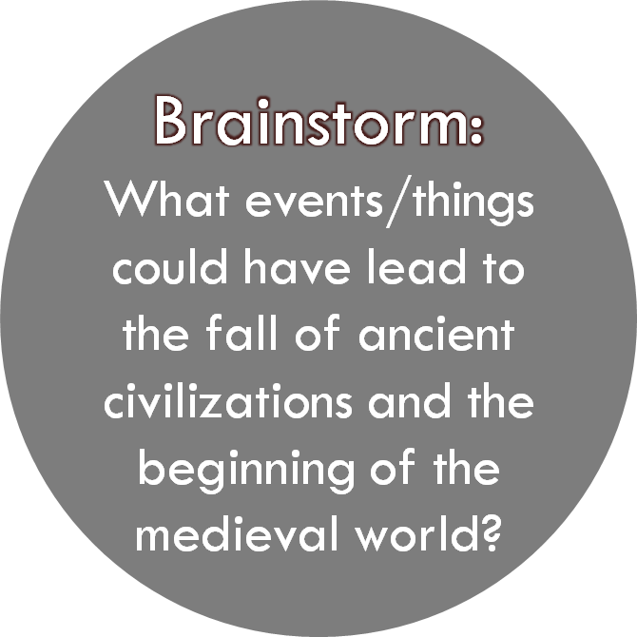

|  |
| --- |
| ______________________________________________________ ______________________________________________________ ______________________________________________________ ______________________________________________________ ______________________________________________________ |

**What will we be covering:**

1.__________________________________________________________________________________  
2.__________________________________________________________________________________

**Main Focus:**

Between the end of the __________ __________ (c. ad 500) and the beginning of the ___________ _____________ (c. 1750), empires and civilisations ________ ______ ________ _________ _______ __________, changing through contact with others.

**WHY?**

Studying the ______ _____ ______ of these civilisations helps us to ___________ changes in the world ________, such as the growing importance of __________ powers.



What do you already know about Ancient Rome?

1. .........................................................................................................................................
2. .........................................................................................................................................
3. .........................................................................................................................................
4. .........................................................................................................................................
5. .........................................................................................................................................
6. .........................................................................................................................................

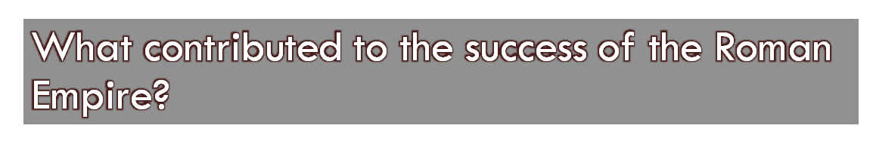

•The Roman Army was highly _____________ and ___________.

• Roman ___________ connected the various parts of the Roman Empire making __________ and the movement of soldiers easier.

•Resources from newly conquered areas and trade increased Rome’s __________.

•Rome learnt from the countries they ______________.

•New ____________ improved standards of living

•People in Rome were united and subdued through ____________.

•Initially there was strong _____________ and administration from Rome.

|  |  |
| --- | --- |
| * Trained * Entertainment * Development * Conquered | * Trade * Wealth * Leadership * Effective * Roads |



•Rome was the most _______________ empire the world had ever seen.

•It’s _____________ and ____________ added to the prestige of the empire.

|  |
| --- |
| ______________________________________________________ ______________________________________________________ ______________________________________________________ ______________________________________________________ ______________________________________________________ |

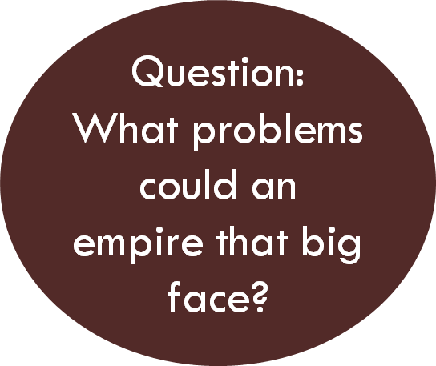

There are 4 areas that attributed to the eventual fall of Rome, and then an immediate cause.

Short Term Problems arose:

1. **P**______________

2. **E**______________

3. **M**_____________

4. **S**______________



|  |  |  |  |
| --- | --- | --- | --- |
| Political | Economical | Military | Social |
| ……………………………………………………………………………………………………………………………………………………………………………………………… | ……………………………………………………………………………………………………………………………………………………………………………………………… | ……………………………………………………………………………………………………………………………………………………………………………………………… | ……………………………………………………………………………………………………………………………………………………………………………………………… |

**Immediate Cause = ____________ ____________**

Threatened from all sides of its ______________ as well as experiencing internal ____________, the might of Rome gradually dwindled until finally, the Roman Emperor of the Western Roman Empire, Romulus Augustus was deposed by the _____________ King, Odoacer on 4th September ______________.

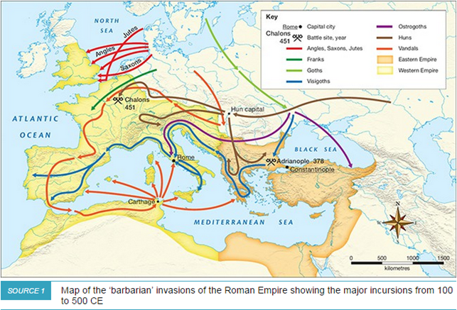

**1. Refer to Source 1 to help you complete the following questions.**

a. The capital of the Eastern Roman Empire was ………………………………………..

b. The capital of the Western Roman Empire was …………….…………………………

c. Another key city in the Western Empire was …………….……….. in northern Africa.

d. Which group invaded a number of the islands of the Mediterranean region? …………….………..…………….………..…………….…………………….………..

e. The Jutes, Angles and Saxons invaded Britain. In which direction did they travel to invade this territory? …………………………………………………………………….

f. A major battle site in 451 CE was ………….……..….in the …………………… Empire.

g. A major battle site in the …………………. Empire was Adrianople in …………..… CE.



|  |  |  |
| --- | --- | --- |
|  | Christianity | Islam |
| When did it begin? | ………………………………….  ………………………………….………………………………… | …………………………………………………………………….………………………………….. |
| Who was the founder? | …………………………………………………………………….………………………………….. | …………………………………………………………………….………………………………….. |
| What is their main text or book? | …………………………………. | …………………………………. |
| What is their view of ‘God’? | ………………………………….………………………………….…………………………………. | ………………………………….………………………………….…………………………………. |
| What do you have to do to be saved? | ………………………………….………………………………….…………………………………. | ………………………………….………………………………….…………………………………. |
| Any other interesting points of comparison? | ………………………………….………………………………….…………………………………. | ………………………………….………………………………….…………………………………. |

# **Voyages of Trade and Discovery**

## **Activity One - WHO WERE THE EXPLORERS? CHOOSE TWO**

CHOOSE TWO and complete the questions below

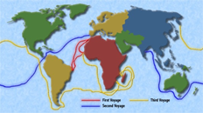

Bartolomeu Diaz Christopher Columbus

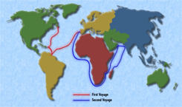

Vasco Da Gama Ferdinand Magella

|  |  |  |
| --- | --- | --- |
|  | 1. | 2. |
| 1) When did they live? | ………………………………….…………………………………. | …………………………………………………….……………………… |
| 2) Why did they explore? | ………………………………….………………………………….…………………………………. | ………………………………….………………………………….…………………………………………. |
| 3) Where did they travel to? | ………………………………….………………………………….…………………………………. | ………………………………….………………………………….…………………………………………. |
| 4) How many voyages did they participate in? | ………………………………….………………………………….………………………………….…………………………………. | ………………………………….………………………………….………………………………………….……………………………………. |
| 5) Why were they such a significant explorer? | ………………………………….………………………………….…………………………………. | ………………………………….………………………………….…………………………………………. |

Choose one of the explorers you have learnt about. Create a:

o Rap or

o Song or

o Poem or

o Cartoon

about your explorer. You may use the internet to find pictures. Be prepared to present to the class!

………………………………….………………………………….………………………………….………………………………….………………………………….………………………………….………………………………….………………………………….………………………………….………………………………….………………………………….………………………………….………………………………….………………………………….………………………………….………………………………….………………………………….………………………………….………………………………….………………………………….………………………………….………………………………….………………….………………………………….………………………………….………………………………….………………………………….………………………………….……